**ASSIGNMENT 6.1**

**We have a dataset of travel data analysis Column Name: Column 1: City pair (Combination of from and to): String Column 2: From location: String Column 3: To Location: String Column 4: Product type: Integer (1=Air, 2=Car, 3 =Air+Car, 4 =Hotel, 5=Air+Hotel, 6=Hotel +Car, 7 =Air+Hotel+Car) Column 5: Adults traveling: Integer Column 6: Seniors traveling: Integer Column 7: Children traveling: Integer Column 8: Youth traveling: Integer Column 9: Infant traveling: Integer Column 10: Date of travel: String Column 11: Time of travel: String Column 12: Date of Return: String Column 13: Time of Return: String Column 14: Price of booking: Float Column 15: Hotel name: String Big Data Development Page 4 You can download the dataset from the below link: https://github.com/prateekATacadgild/DatasetsForCognizant/blob/master/TravelData.txt Problem statement**

**1: Find out how many people has chosen their destination as MIA and MCO Problem statement**

**2: Find out the number of people undertaken the trips from the places MIA and HOU Problem statement**

**3: Find out how many people has chosen airline mode of travel for the places LAS and LAX**

**DRIVER**

**Q1**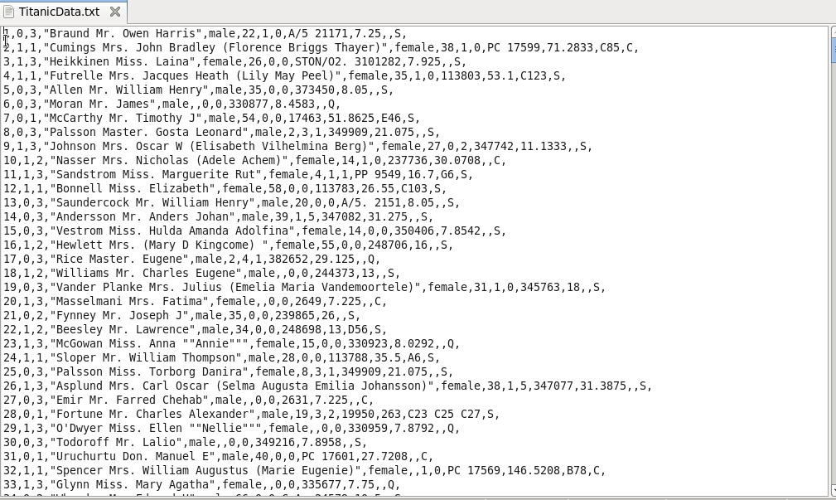

**DRIVER**

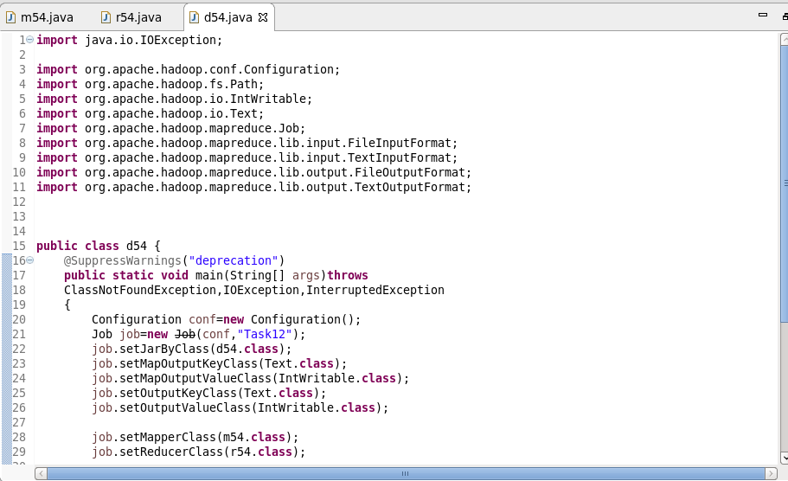

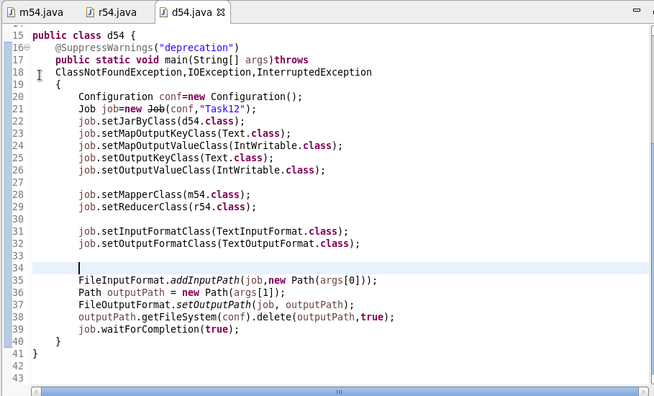

**MAPPER**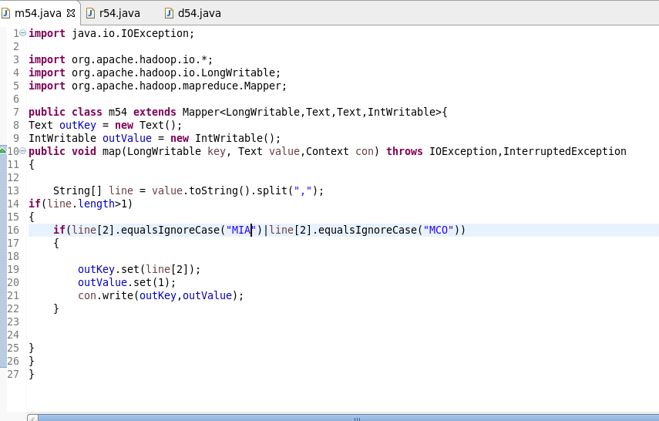

**REDUCER**

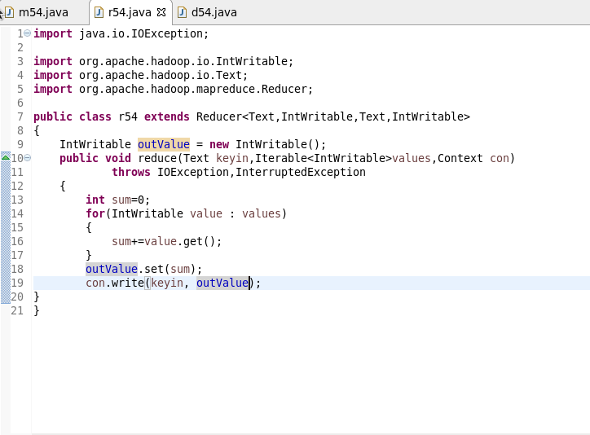

**OUTPUT**

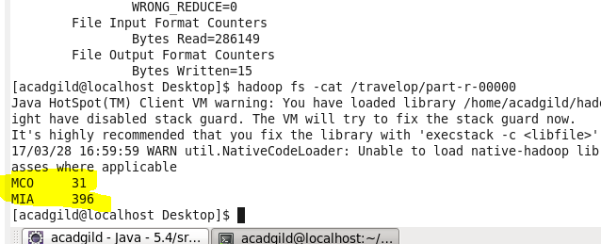

**Q2**

**MAPPER**

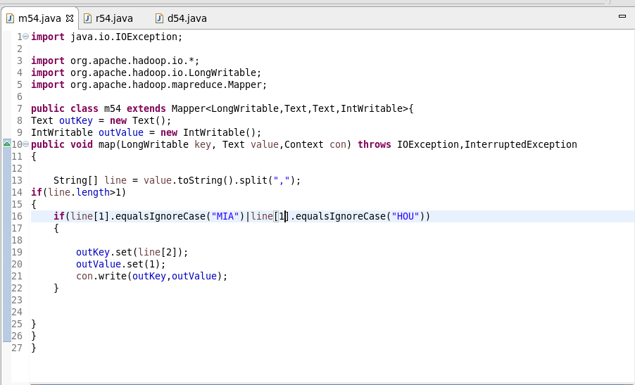

**REDUCER**



**OUTPUT**

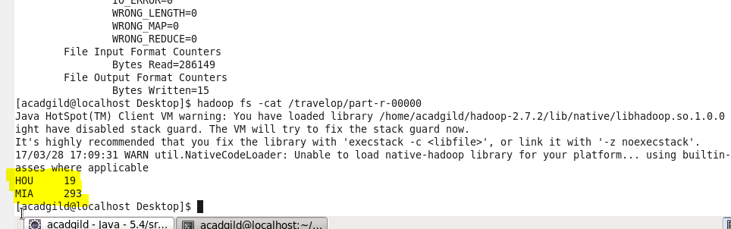

**Q3**

**MAPPER**

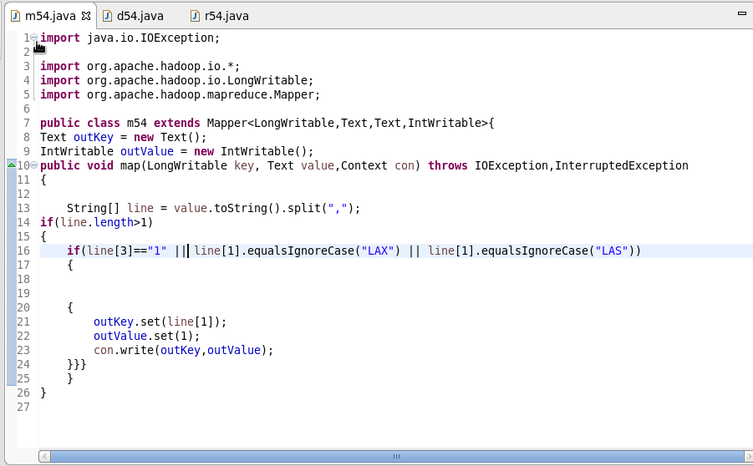

**REDUCER**



**OUTPUT**

